**MEDICINE MONITORING SYSTEM**

A Dissertation submitted

for the partial fulfillment of the degree of

**Bachelors of Technology in**

**Computer Science Engineering**

**(Session - 2019)**

**Guided By: Submitted By:**

**Sabbir Poonawala Rahul Bajaj (768888)**

**Trainer Intern**

**Department of Computer Science Engineering**

**Chandigarh Group Of Colleges, Landran**

**(https://www.cgc.edu.in/)**

**May 2019**

**Dissertation Approval Sheet**

The dissertation entitled **“Medicine Monitoring System**”submitted by **Rahul Bajaj** is approved as partial fulfilment for the award of **Bachelors of Technology in Computer Science Engineering** degree by **Chandigarh Group of Colleges, Landran**

**Internal Examiner External Examiner**

**Director**

**Chandigarh Group of Colleges, Landran**

**(https://www.cgc.edu.in/)**

**May 2019**

**Candidate Declaration**

We hereby declare that the work which is being presented in this project entitled **Medicine Monitoring System** in partial fulfilment of degree of Bachelor of Technology in Computer Science Engineering is an authentic record of our own work carried out under the supervision and guidance of **Sabbir Poonawala**, **Trainer.**

We are fully responsible for the matter embodied in this project in case of any discrepancy found in the project and the project has not been submitted for the award of any other degree.

**Date:**

**Place:**

**Rahul Bajaj**

**CERTIFICATE**

|  |  |  |  |
| --- | --- | --- | --- |
| This is to certify that the project report entitled “**Medicine Monitoring System”.**   |  |  | | --- | --- | | RAHUL BAJAJ  PARTH SHARMA  PAYUSH BADHALA  SARTH SHARMA  NITIN VERMA | 1533212  1525515  1525516  1503485  15BCS1768 |   in partial fulfilment of the requirements for the award of the Degree of Bachelor of Technology in Computer Science department and Computer Science department is a bonfire record of the work carried out under my(our) guidance and supervision at Chandigarh Group of Colleges, PTU (Deemed to be University). | |
| Signature of Supervisor 1  Prof.  Chandigarh Group of Colleges  PTU (Deemed to be University) | Signature of Supervisor 2  Prof.  Chandigarh Group of Colleges  PTU (Deemed to be University) |

|  |  |
| --- | --- |
| The Project was evaluated by us on _____________ | |
|  | |
| EXAMINER 1 | EXAMINER 2 |
| EXAMINER 3 | EXAMINER 4 |

**ACKNOWLEDGEMENT**

For the successful completion of this project, I'd extend a sincere thanks to our project guide as well as trainer Mr. Sabbir Poonawala Sir, who has been there with us while building the complete code from scratch. Without his guidance and teaching, it'd have been impossible of us to create the project.

I'm also grateful to our batch owners and people who've helped us out in every way possible, Shilpa Mahajani Ma’am, Mohit Kariya Sir, Gerard Thomas Sir and Komal Sanjay Pawar Ma’am. Without them, internship at such a huge company would have not been completed successfully. They ensured our smooth functioning and handled all the quirks and doubts while the sessions which helped us a lot in order to calmly finish the project.

I'd also like to thank our college director Mr. P.N. Hrisheekesha Sir for giving us such an amazing opportunity to work through the college semester in order to get a corporate experience and education. It is only because of his thought that we were able to gain such a training with a parallel balance of college academics.

**ABSTRACT**

This report is aimed at documenting the “**Medicine Monitoring System**” that has been developed as a solution of a common interface between the admin and the branch admins. While starting with the project we went through some similar existing platforms that inspired the project to be developed in the first place, however it provided the motivation to do it even better. An all-inclusive pharmacy management tool is necessary for seamless operations of an enterprise pharmacy company.

Centralized inventory management to avert expiry of medicines & drugs – which also helps to oversee product burnout at different branches of the pharmacy and be supplied with relevant medicines & drugs from the inventory to the branch. This also helps to avert non-availability of medicines at a branch store at any given time.

The solution developed will address the objective in a holistic manner and will have all the features and functionalities which shall let the hospital be able to record & assimilate live inventory data from the branch stores and trigger the need to supply necessary drugs & medicines to the branch store that is running out of stock.

**INDEX**

**TABLE OF CONTENTS Page No**

**Dissertation Approval Sheet ii**

**Candidate Declaration iii**

**Certificate iv**

**Acknowledgements v**

**Abstract vi**

**Chapter 1 Introduction**

1.1 Purpose of this document **viii**

1.2 Project Overview **viii**

**Chapter 2 Literature Survey**

2.1 Methodology **xi**

2.2 Technologies and Tools **xii**

**Chapter 3 Analysis**

3.1 Software Requirements **xv**

3.2 Hardware Requirements  **xv**

**Chapter 4 Design**

4.1 Diagrams  **xvii**

4.2 Tables  **xx**

**Chapter 5 Conclusion**  **xxii**

**References** **xxiii**

**CHAPTER 1**

**INTRODUCTION**

1. . **Introduction**

**1.1 Purpose of this document**

This document is aimed at:

* Providing the necessary inputs to the detailed requirements gathering phase and further on for the SDLC processes.
* This document also serves to establish the traceability between the Business Objectives and the requirements identified in the proposed solution and how they satisfy the stated objectives.
* Provide expectation traceability in terms of the requirements and the user expectation
* Serves as a formal template for documenting the Business Requirements which also includes statutory and regulatory requirements.

The purpose of this document is to systematically capture requirements for the project and the system to be developed. Functional requirements are captured in this document. It also serves as the input for the project scoping.

**1.2 Project Overview**

1.2.1 Objectives

Below are the objectives that shall be fulfilled post the execution of this project:

Medicine Monitoring system will create and store information of Branch Admin and Medicines. Stores the information on the request for Medicine and the stock details.

* Create Branch Admin information
* Maintain Branch Admin information
* Create and maintain Medicines information
* Updating the status of request for medicine
* Storing the requests raised by branch admin and the response from the admin
* Storing stock details of medicines

The solution developed will address the objective in a holistic manner and will have all the features and functionalities which shall let the hospital be able to record & assimilate live inventory data from the branch stores and trigger the need to supply necessary drugs & medicines to the branch store that is running out of stock.

**CHAPTER 2**

**LITERARY SURVEY**

1. **Literary Survey**

**2.1 Methodology**

* **SDLC**:

In [software engineering](https://en.wikipedia.org/wiki/Software_engineering), a **software development** process is the process of dividing [software development](https://en.wikipedia.org/wiki/Software_development) work into distinct phases to improve [design](https://en.wikipedia.org/wiki/Software_design), [product management](https://en.wikipedia.org/wiki/Software_product_management), and [project management](https://en.wikipedia.org/wiki/Software_project_management). It is also known as a software development life cycle. The methodology may include the pre-definition of specific [deliverables](https://en.wikipedia.org/wiki/Deliverable) and artefacts that are created and completed by a project team to develop or maintain an application.

Most modern development processes can be vaguely described as [agile](https://en.wikipedia.org/wiki/Agile_software_development). Other methodologies include [waterfall](https://en.wikipedia.org/wiki/Waterfall_model), [prototyping](https://en.wikipedia.org/wiki/Software_prototyping), [iterative and incremental development](https://en.wikipedia.org/wiki/Iterative_and_incremental_development), [spiral development](https://en.wikipedia.org/wiki/Spiral_development), [rapid application development](https://en.wikipedia.org/wiki/Rapid_application_development), and [extreme programming](https://en.wikipedia.org/wiki/Extreme_programming).

Some people consider a life-cycle "model" a more general term for a category of methodologies and a software development "process" a more specific term to refer to a specific process chosen by a specific organization.

**Agile:**

"**Agile software development**" refers to a group of software development methodologies based on iterative development, where requirements and solutions evolve via collaboration between self-organizing cross-functional teams

Agile software development uses iterative development as a basis but advocates a lighter and more people-centric viewpoint than traditional approaches. Agile processes fundamentally incorporate iteration and the continuous feedback that it provides to successively refine and deliver a software system.

There are many agile methodologies, including:

[Dynamic systems development method](https://en.wikipedia.org/wiki/Dynamic_systems_development_method) (DSDM)

[Kanban](https://en.wikipedia.org/wiki/Kanban_(development))

[Scrum](https://en.wikipedia.org/wiki/Scrum_(development))

**Client–server model:**

**Client–server model** is a [distributed application](https://en.wikipedia.org/wiki/Distributed_application) structure that partitions tasks or workloads between the providers of a resource or service, called [servers](https://en.wikipedia.org/wiki/Server_(computing)), and service requesters, called [clients](https://en.wikipedia.org/wiki/Client_(computing)).[[1]](https://en.wikipedia.org/wiki/Client%E2%80%93server_model#cite_note-1) Often clients and servers communicate over a [computer network](https://en.wikipedia.org/wiki/Computer_network) on separate hardware, but both client and server may reside in the same system. A server [host](https://en.wikipedia.org/wiki/Host_(network)) runs one or more server programs which share their resources with clients. A client does not share any of its resources, but requests a server's content or service function. Clients therefore initiate communication sessions with servers which await incoming requests.

**2.2Technology and Tools**

* + **Front End:**
    - **Java (HTML, CSS, JavaScript)** 
      * **HTML:**

**Hypertext Markup Language** (HTML) is the standard [markup language](https://en.wikipedia.org/wiki/Markup_language) for creating [web pages](https://en.wikipedia.org/wiki/Web_page) and [web applications](https://en.wikipedia.org/wiki/Web_application). With [Cascading Style Sheets](https://en.wikipedia.org/wiki/Cascading_Style_Sheets) (CSS) and [JavaScript](https://en.wikipedia.org/wiki/JavaScript), it forms a triad of [cornerstone](https://en.wikipedia.org/wiki/Cornerstone) technologies for the [World Wide Web](https://en.wikipedia.org/wiki/World_Wide_Web).

[Web browsers](https://en.wikipedia.org/wiki/Web_browser) receive HTML documents from a [web server](https://en.wikipedia.org/wiki/Web_server) or from local storage and [render](https://en.wikipedia.org/wiki/Browser_engine) the documents into multimedia web pages. HTML describes the structure of a web page [semantically](https://en.wikipedia.org/wiki/Semantic_Web) and originally included cues for the appearance of the document.

**CSS:**

**Cascading Style Sheets**(CSS) is a [style sheet language](https://en.wikipedia.org/wiki/Style_sheet_language) used for describing the [presentation](https://en.wikipedia.org/wiki/Presentation_semantics) of a document written in a [markup language](https://en.wikipedia.org/wiki/Markup_language) like [HTML](https://en.wikipedia.org/wiki/HTML). CSS is a cornerstone technology of the [World Wide Web](https://en.wikipedia.org/wiki/World_Wide_Web), alongside HTML and [JavaScript](https://en.wikipedia.org/wiki/JavaScript).

CSS is designed to enable the separation of presentation and content, including [layout](https://en.wikipedia.org/wiki/Page_layout), [colors](https://en.wikipedia.org/wiki/Color), and [fonts](https://en.wikipedia.org/wiki/Typeface).[[3]](https://en.wikipedia.org/wiki/Cascading_Style_Sheets#cite_note-3) This separation can improve content [accessibility](https://en.wikipedia.org/wiki/Accessibility), provide more flexibility and control in the specification of presentation characteristics, enable multiple [web pages](https://en.wikipedia.org/wiki/Web_page) to share formatting by specifying the relevant CSS in a separate .css file, and reduce complexity and repetition in the structural content.

**JavaScript:**

**JavaScript**often abbreviated as JS, is a [high-level](https://en.wikipedia.org/wiki/High-level_programming_language), [interpreted](https://en.wikipedia.org/wiki/Interpreted_language) [programming language](https://en.wikipedia.org/wiki/Programming_language) that conforms to the [ECMAScript](https://en.wikipedia.org/wiki/ECMAScript) specification. It is a programming language that is characterized as [dynamic](https://en.wikipedia.org/wiki/Dynamic_programming_language), [weakly typed](https://en.wikipedia.org/wiki/Weak_typing), [prototype-based](https://en.wikipedia.org/wiki/Prototype-based_programming) and [multi-paradigm](https://en.wikipedia.org/wiki/Multi-paradigm_programming_language).

Alongside [HTML](https://en.wikipedia.org/wiki/HTML) and [CSS](https://en.wikipedia.org/wiki/CSS), JavaScript is one of the core technologies of the [World Wide Web](https://en.wikipedia.org/wiki/World_Wide_Web). JavaScript enables interactive [web pages](https://en.wikipedia.org/wiki/Web_page) and is an essential part of [web applications](https://en.wikipedia.org/wiki/Web_application). The vast majority of [websites](https://en.wikipedia.org/wiki/Website) use it, and major [web browsers](https://en.wikipedia.org/wiki/Web_browser) have a dedicated [JavaScript engine](https://en.wikipedia.org/wiki/JavaScript_engine) to execute it.

* + **Middleware:**
    - **Java (Java Servlet, JDBC)**

**Java Servlet:**

A Java servlet processes or stores a [Java class](https://en.wikipedia.org/wiki/Java_class) in [Java EE](https://en.wikipedia.org/wiki/Java_EE) that conforms to the Java Servlet API a standard for implementing Java classes that respond to requests. Servlets could in principle communicate over any [client–server](https://en.wikipedia.org/wiki/Client%E2%80%93server_model) protocol, but they are most often used with the [HTTP](https://en.wikipedia.org/wiki/Hypertext_Transfer_Protocol).

Thus "servlet" is often used as shorthand for "HTTP servlet". Thus, a [software developer](https://en.wikipedia.org/wiki/Software_developer) may use a servlet to add [dynamic content](https://en.wikipedia.org/wiki/Dynamic_web_page) to a [web server](https://en.wikipedia.org/wiki/Web_server) using the [Java platform](https://en.wikipedia.org/wiki/Java_platform). The generated content is commonly [HTML](https://en.wikipedia.org/wiki/HTML), but may be other data such as [XML](https://en.wikipedia.org/wiki/XML) and more commonly, JSON. Servlets can maintain [state](https://en.wikipedia.org/wiki/State_(computer_science)) in [session](https://en.wikipedia.org/wiki/Session_(computer_science)) variables across many server transactions by using [HTTP cookies](https://en.wikipedia.org/wiki/HTTP_cookie), or [URL mapping](https://en.wikipedia.org/wiki/URL_mapping).

**JDBC:**

**Java Database Connectivity** (JDBC) is an [application programming interface](https://en.wikipedia.org/wiki/Application_programming_interface) (API) for the programming language [Java](https://en.wikipedia.org/wiki/Java_(programming_language)), which defines how a client may access a [database](https://en.wikipedia.org/wiki/Database). It is a Java-based data access technology used for Java database connectivity. It is part of the Java Standard Edition platform, from [Oracle Corporation](https://en.wikipedia.org/wiki/Oracle_Corporation). It provides methods to query and update data in a database, and is oriented towards [relational databases](https://en.wikipedia.org/wiki/Relational_database). A JDBC-to-[ODBC](https://en.wikipedia.org/wiki/ODBC) bridge enables connections to any ODBC-accessible data source in the [Java virtual machine](https://en.wikipedia.org/wiki/Java_virtual_machine) (JVM) host environment.

**Backend: {**can run on any database}

* + - **Oracle/SQL Server**

**MySQL:**

**MySQL**  is an [open source](https://en.wikipedia.org/wiki/Open-source_software) relational database management system (RDBMS). "[SQL](https://en.wikipedia.org/wiki/SQL)", is abbreviation for [Structured Query Language](https://en.wikipedia.org/wiki/Structured_Query_Language).

MySQL is [free and open-source software](https://en.wikipedia.org/wiki/Free_and_open-source_software) under the terms of the [GNU General Public License](https://en.wikipedia.org/wiki/GNU_General_Public_License), and is also available under a variety of [proprietary](https://en.wikipedia.org/wiki/Proprietary_software) licenses. MySQL was owned and sponsored by the [Swedish](https://en.wikipedia.org/wiki/Sweden) company [MySQL AB](https://en.wikipedia.org/wiki/MySQL_AB), which was bought by Sun Microsystems (now [Oracle Corporation](https://en.wikipedia.org/wiki/Oracle_Corporation)).

**CHAPTER 3**

**ANALYSIS**

1. **Analysis**
   1. **Software Requirements**

* Operating System: Linux OS, Windows 7/8/10
* IDE: Eclipse IDE for Java EE Developers (Oxygen)
* Server: MySQL Workbench Server 6.2, Tomcat 8.5
* RDBMS: MySQL
* Environment: JDK 1.6, 1.7, 1.8 for Java 6, 7, 8 configured on the workstation

**3.2 Hardware Requirements**

* Processor: 1.7GHz Intel Core2Duo or above
* RAM: 4 GB
* Hard Disk: 100 GB-1 TB
* Network Adaptor

**CHAPTER 4**

**DESIGN**

1. **Design**
   1. **Diagrams**

**Admin Process flow**



* 1. **Tables**

Table 1.0(Admin)

|  |  |  |  |  |  |
| --- | --- | --- | --- | --- | --- |
| Name | Field Type | | Data Type | Mandatory | Possible Values |
| Admin ID | Text(10) | | Alphabetic | Yes | System Generated |
| First Name | Text(50) | Alphabetic | | Yes | |
| Last Name | Text(50) | Alphabetic | | Yes | |
| Age | Numeric(2) | Numeric | | Yes | |
| Gender | Drop Down | NA | | Male, Female | |
| DoB | Text(10) | Alphanumeric | | Yes | |
| Contact Number | Text(10) | Numeric | | Yes | |
| Alt Contact Number | Text(10) | Numeric | | No | |

Table 2.0(Branch Admin)

|  |  |  |  |  |
| --- | --- | --- | --- | --- |
| Name | Field Type | Data Type | Mandatory | Possible Values |
| Branch Admin ID | Text(10) | Alphabetic | Yes | System Generated |
| First Name | Text(50) | Alphabetic | Yes | |
| Last Name | Text(50) | Alphabetic | Yes | |
| Age | Numeric(2) | Numeric | Yes | |
| Gender | Drop Down | NA | Male, Female | |
| DoB | Text(10) | Alphanumeric | Yes | |
| Contact Number | Text(10) | Numeric | Yes | |
| Alt Contact Number | Text(10) | Numeric | No | |
| Email ID | Text(50) | Alphanumeric | Yes | |
| Branch Name | Text(50) | Alphabetic | Yes | |
| Address Line 1 | Text(100) | Alphanumeric | Yes | |
| Address Line 2 | Text(100) | Alphabetic | No | |
| City | Text(50) | Alphabetic | Yes | |
| State | Text(50) | Alphabetic | Yes | |
| Zip Code | Text(10) | Numeric | Yes | |

Table 3.0(Medicine)

|  |  |  |  |  |
| --- | --- | --- | --- | --- |
| Field Name | Field Type | Data Type | Mandatory | Possible Values |
| Medicine ID | Auto-generated(8) | Numeric | Yes | Non-editable system generated |
| Medicine Description | Text(200) | Alphabetic | Yes | |
| Cure for | Text(100) | Alphabetic | Yes | |
| Manufacturing company | Text(50) | Alphabetic | Yes | |
| Dosage | Numeric(3) | Numeric | Yes | mg |
| Prescribed for | Text(1) | Alphabetic | Yes | A – Adult  C - Children |

|  |  |  |  |  |
| --- | --- | --- | --- | --- |
|  |  |  |  |  |

Table 4.0(Branch Admin Request)

|  |  |  |  |  |  |
| --- | --- | --- | --- | --- | --- |
| Field Name | Field Type | Data Type | | Mandatory | Possible Values |
| Request ID | Auto-generated(8) | Numeric | | Yes |  |
| Branch Admin ID | Text(10) | Alphabetic | | Yes |  |
| Request date | Text(10) | Alphanumeric | | Yes |  |
| MedicineID1 | Numeric | Numeric | | Yes |  |
| Quantity1 | Numeric(3) | Numeric | | Yes |  |
| MedicineID2 | Numeric | Numeric | | No |  |
| Quantity2 | Numeric(3) | Numeric | | No |  |
| MedicineID3 | Numeric | Numeric | | No |  |
| Quantity3 | Numeric(3) | Numeric | | No |  |
| MedicineID4 | Numeric | Numeric | | No |  |
| Quantity4 | Numeric(3) | Numeric | | No |  |
| MedicineID5 | Numeric | Numeric | | No |  |
| Quantity5 | Numeric(3) | Numeric | | No |  |
| Other Info | Text(200) | Alphabetic | | No |  |
| Admin process date | Text(10) | Alphanumeric | | No |  |
| Admin Response | Text(1) | Alphabetic | No | | A-Approve  D-Deny |
| Admin remarks | Text(300) | Alphanumeric | | No |  |

**CODES REQUIRED FOR FRONTEND(HTML/JSP)**

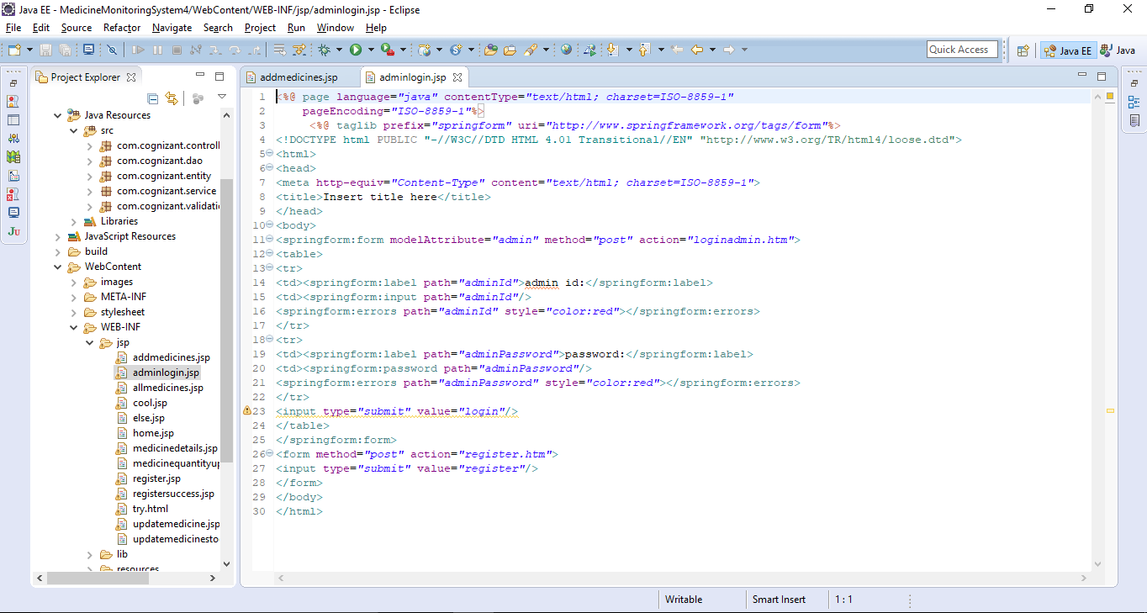

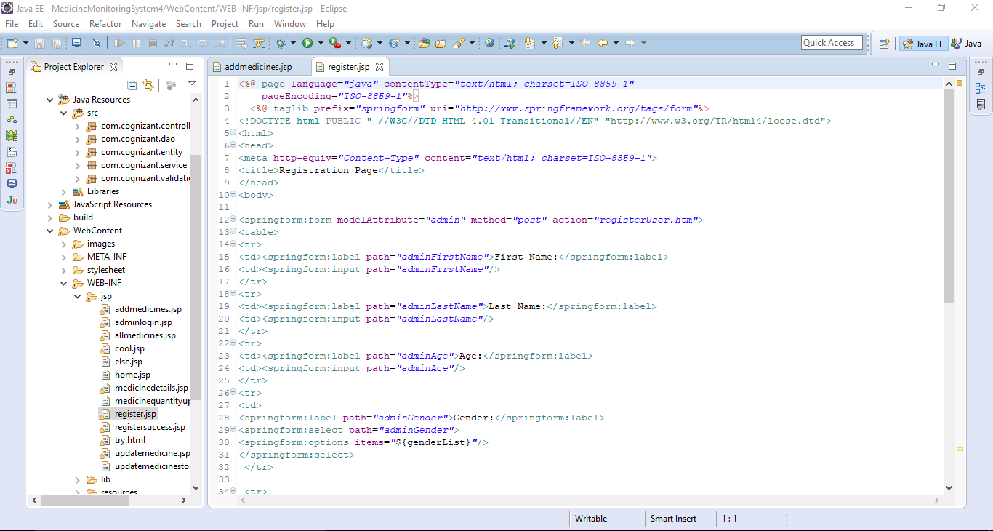

**CODES REQUIRED FOR MIDDLEWARE(HTML/JSP)**

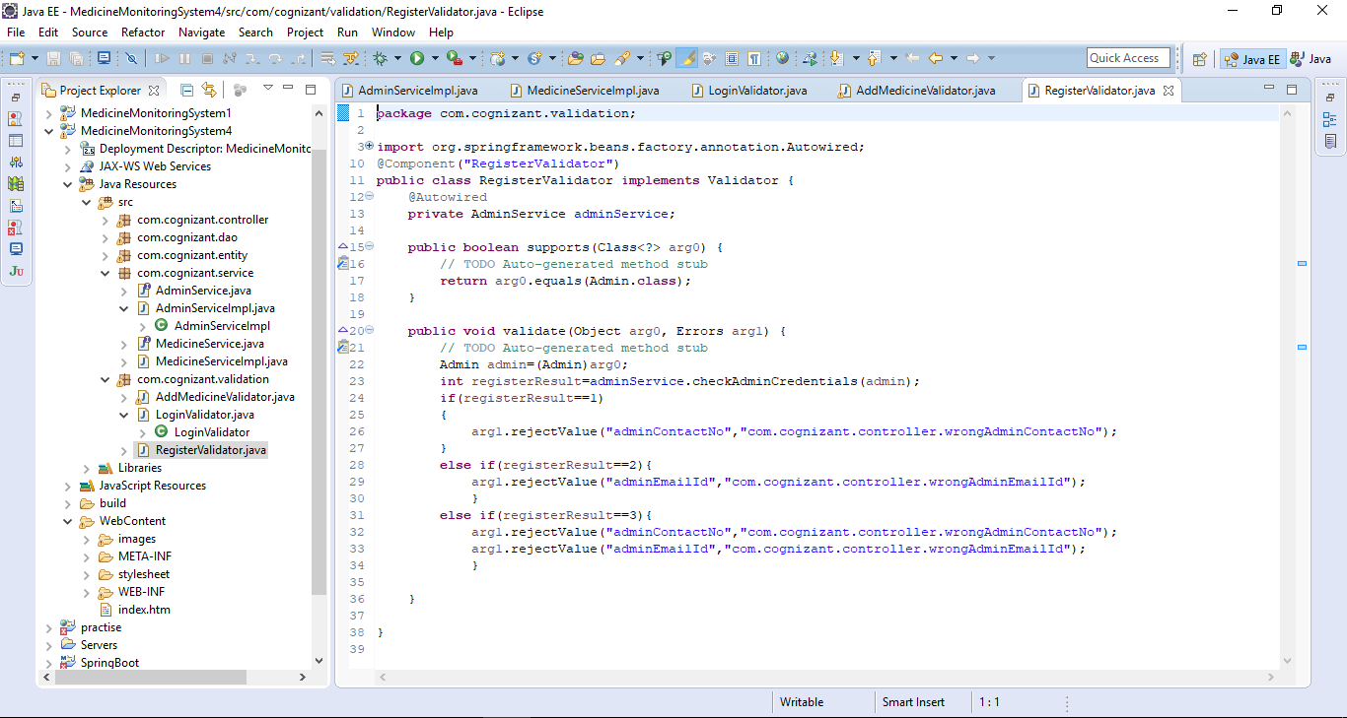

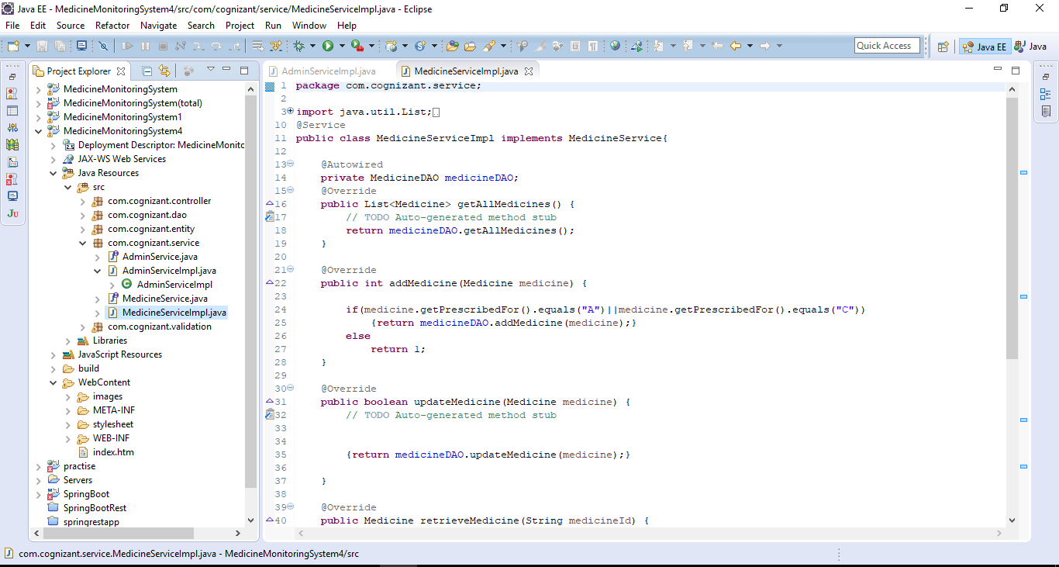

**CODES REQUIRED FOR BACKEND(HTML/JSP)**

